Create and Manage Workspaces in Power BI
Introduction
A workspace is a centralized repository in which you can collaborate with colleagues and teams to create collections of reports and dashboards

Workspaces offer the following benefits:
- Focused collaboration efforts, you can use workspaces to house reports and dashboards for use by multiple teams
- Ability to share and present reports and dashboards in a single environment
- Assurance that the highest level of security is maintained by controlling who can access datasets, reports, and dashboards

Distribute A Report or Dashboard
By creating a workspace in Power BI, you can:
- house your reports in one location
- make them shareable
- collaborate with other teams
- update reports

Create a Workspace
Can be done in the Power BI Service section

Workspaces can be added to a specific OneDrive and then choose whether this workspace will be a part of a decided capacity or not

Dedicated capacities are Power BI Premium features that ensures that your workplace will:
have its own computational resources as opposed to sharing with other users

Assign Workspace Roles
Appropriate access should be given to those who need it.

Workspace roles allow you to designate who can do what within a workspace:

The abilities of role types in a workspace include:

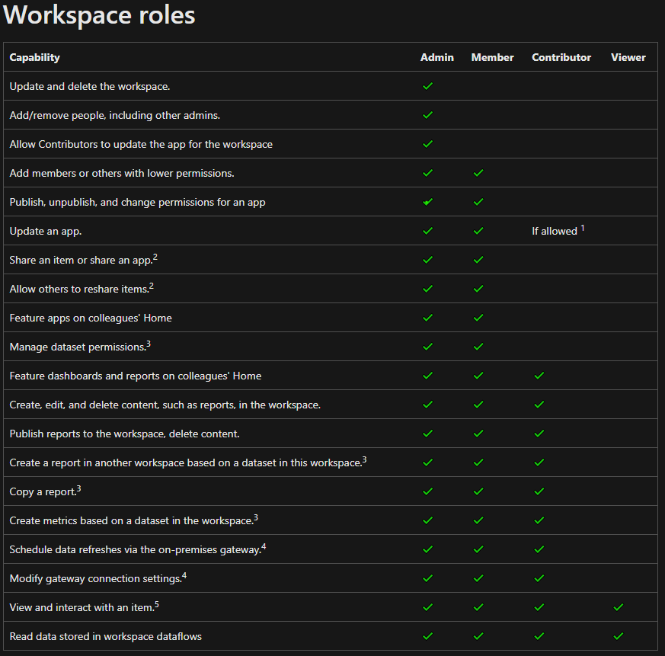
To assign these roles to users, go to workspace that you’ve created,
=> and, in the upper-left corner, select Access

In the Access window you can add:
- Email addresses of individual users
- Mail-enabled security groups
- Distribution lists
- Microsoft 365 groups
- Regular security groups

and assign them specific roles

Create and Configure an App
You would want to add content to your App workspace

Content can be in the form of:
- Reports
- Dashboards
- Datasets
- Dataflows
- and so on.,

An app (application) is a published, read-only window into your data for mass distribution and viewing

When ready to share apps with your user, you can publish the app – this process requires a Power BI license

Consuming or viewing an app requires a Pro license

After adding content to the app workspace, you can then create the app
=> You can choose to create a new report, dataset, streaming dataset, or dataflow to the app through the + New button

You can also import already-existing reports from Power BI Desktop and add them to the workspace app

You can also configure your app and turn on the option to include the report or dashboard in the app when you publish
if you do not want to include the report or dashboard in the app, you can turn off this option

The Create App button on the upper-right of the ribbon will allow you to create the app
=> A window will then pop-up,
=> Under its Navigation tab, you can change the order in which the content is oriented for the user by creating a custom navigation pane
=> You can also add external content, e.g., a YouTube video or PowerPoint slide deck

Under the Permissions tab you can:
- Grant access to all users in your organization or choose which users have access.
- Give users build and share permissions
  - which means they can create and share content in the app

Build Permission
Build permissions allow your users to connect to underlying datasets so that they can reuse and build their own reports by using the same dataset

Build permission are required if your users want to export the underlying data or build new content on top of the data

You can also allow users to only create a copy of the report to view in another workspace, where they can modify and delete visuals according to their needs

You can also give your users Share permissions so that they can share underlying datasets and reports

An example of some of the permissions can be seen below

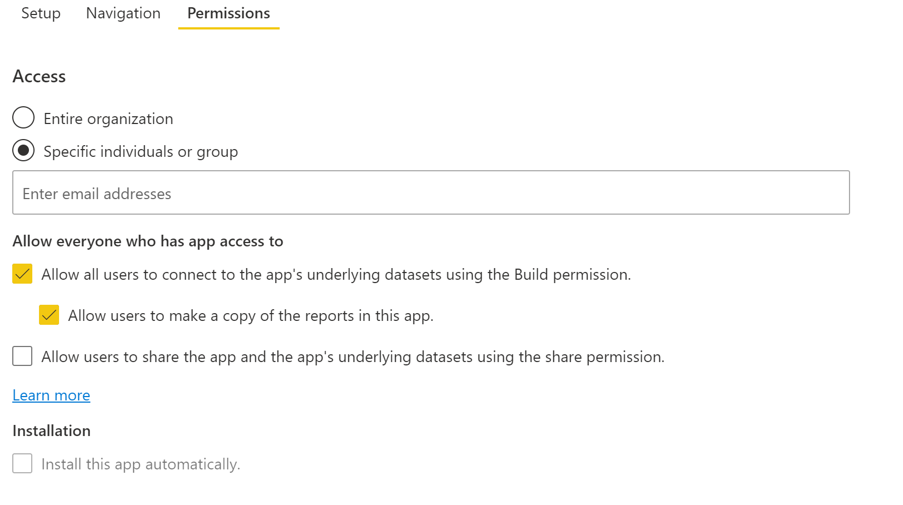

Update Workspaces
In order to make changes, make the necessary updates in the reports or dashboards

The workspace acts as a staging area where you can make any changes you want, but they will not be added to the app

After completion, click the Update app in the upper-right corner of the ribbon

Dataset and dataflow updates are updated immediately

When you make changes to an app, you can also make changes to the:
- Setup navigation
- Permissions tab

Monitor Usage and Performance
Crucial because:
- focuses your efforts for improvements
  - areas that experience worst performance – concentrate efforts for improvements in those areas
- quantifies the impact of your reports

Usage and performance metrics are available features. With these you can:
- view who is using your reports
- what actions are being done on the reports
- what performance issues exists

Configure and View Usage Metric Reports
Usage metric reports are available and can only be accessed by users with the role type:
- Admin
- Member
- Contributor

Accessible in the pertinent workspace through the elipsis (…) section

Usage metrics report will be presented in a dashboard.

In the report usage tab, you can view details such as:
- Viewers per day
- Unique viewers per day
  - does not include users who returned to the same reports multiple times
- Shares per day
- Total Views
- Total Viewers
- Total Shares
- Total views and share rankings
  - compares how your report is doing compared to other reports in the app
- Views by Users
  - details about specific user that viewed the dashboard

In the report performance tab, you can view metrics such as:
- Typical opening time
  - How long it takes, at the fiftieth percentile, to open the report
- Opening time trend
  - How the typical opening time changes over time
  - This metric can tell you how the report is performing as the number of users start to grow
- Daily/7-Day Performance charts
  - Highlight the performance for 10, 50, and 90 percent of the open-report actions every day and over a seven-day period
- Filters for date
  - How the performance changes according to the day

Recommend a Development Life Cycle Strategy
Development process is iterative

It typically requires:
- building an initial solution
- testing the solution in a different environment
- returning to make necessary revisions

This process is known as a development life cycle

Deployment pipelines manages content in dashboards, reports, and datasets between different environments in the development life cycle

Deployment Pipelines (A Power BI Premium feature)
The advantages of using a development pipeline:
- Increased productivity
  - Reuse previous deployment pipelines, ensuring efforts aren’t duplicated
- Faster delivery of content
  - Report developments become more streamlined
  - Takes less time to get to production
- Lower human intervention required
  - Having the ability to reuse deployment pipelines means a decreased chance of error associated with moving content from one environment to another

Development Environments
Development and collaboration occur in different stages

Reports and dashboards are built in and iterated on a series of controlled stages, or environments where several tasks occur:
- Development
  - The location in which dashboard developers or data modellers can build new content with other developers.
  - The stage is first in the deployment pipeline
- Test
  - Where a small group of users and user acceptance testers can see and review new reports, provide feedback and test the reports with larger datasets for bugs and data inconsistencies before it goes into production
- Production
  - Where an expansive user audience can use tested reports that are reliable and accurate
  - This stage is the final one in the deployment pipeline

Troubleshoot using Data Lineage
The Lineage view feature in Power BI allows you to:
- quickly refresh datasets
- see the relationships between the artifacts in a workspace and their external dependencies

Data Lineage
Data Lineage refers to the:
path that data takes from the data source to the destination

Lineage view feature is crucial because it:
- Simplifies the troubleshooting process
  - you can see the path the data takes from source to destination and determine pain points and bottlenecks
- Allows you to manage your workspaces and observe the impact of a single change in one dataset to reports and dashboards
- Saves time
  - simplifies tasks of identifying reports and dashboards that haven’t been refreshed

Use the Lineage View
Lineage view is only accessible to:
- Admin
- Contributor
- Member
roles

It requires a Power BI Pro license and is only available for app workspaces

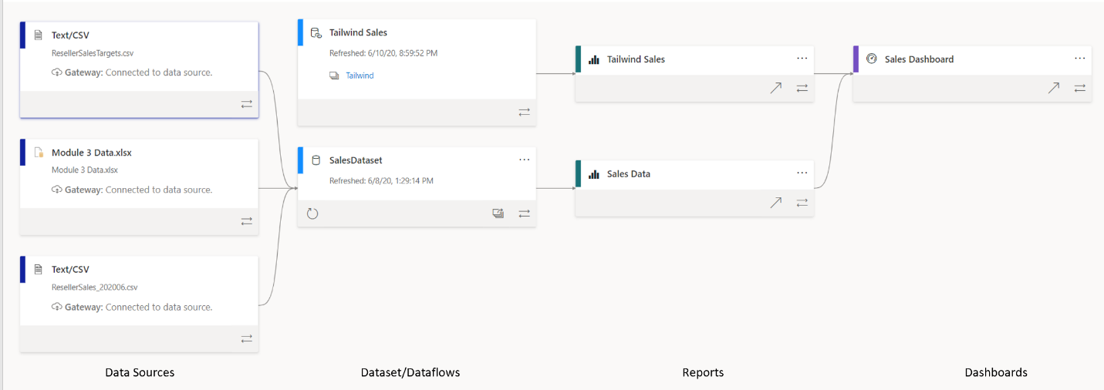
The image below is an example of a data lineage for an example workspace

The view shows all of the artifacts in the workspace

Artifacts include data sources, datasets, and dataflows, reports, and dashboards.

Each card represents an artifact

The arrows in between the cards represent the flow of data or the relationship between different artifacts.

By following the arrows from left to right, you can observer the flow of data from the source to the destination

Data Sources
This group of cards tells you the type of data source (e.g., Text/CSV) and the Gateway

Double clicking will get you more details about the file path and connection status

Gateway
tells you the source of your data

If you are connected through an on-premise data gateway, this card will tell you more information about the gateway

Datasets/Dataflows
often datasets/dataflows can connect to external data sources, such as SQL server, or to external datasets in other workspaces
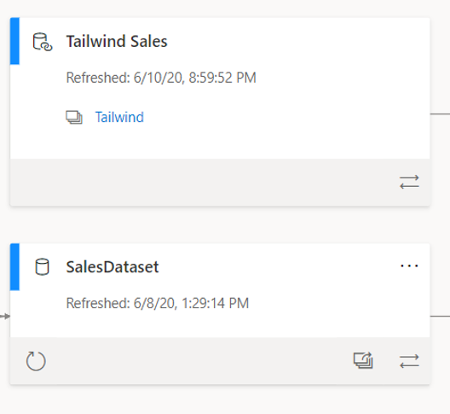

As seen above, the card tells you:
- when the dataset was last refreshed

and you can manually refresh the dataset by selecting the circular arrow icon on the lower-left corner of the card

This ensures that your dataset refreshes are quick and uncomplicated

Double-clicking on the card allows you to see the metadata, which tells you:
- the sensitivity
- who the dataset was configured by
- last refresh date
- names and count of tables within this dataset

You can also view the Impact Analysis window

Impact Analysis window
A window that pops-up after clicking the overlapping windows icon on the lower-right corner of a dataset card

Tells you:
- how many workspaces, reports, and dashboards that this dataset is a part of
- how many views that this dataset has gathered

Allows you to pinpoint datasets that are not being used or looked at.

Reports and Dashboards
Possess similar functionality as the data source and dataset cards

You can enable/disable whether you want to include this report or dashboard within the app

Configure Data Protection
As enterprises grow, so does their data.

Often strict requirements and regulations, must be applied to ensure that this sensitive data is secure.

Hence, sensitive data must remain secure.

Different ways this can be done:
- Use Microsoft sensitivity labels to label dashboards, reports, datasets, and dataflows by using the same taxonomy that is used to classify and protect files in Microsoft 365
- Add more protection measures such as encryption and watermarks when exporting data
- Use Microsoft Cloud App Security to monitor and investigate activities in Power BI

Sensitivity Labels
Specify which data can be exported

Configured externally to Power BI and Power BI allows you to quickly use them in your reports and dashboards

Labels allow you to define and protect content, even outside of Power BI

Datasets, reports, and dashboards can use sensitivity labels to protect information/data

There are varying levels of Sensitivity labels:
- None
- Personal
- General
- Confidential
- Highly Confidential

You can also define your own security label

The varying levels of Sensitivity labels are applied into individual datasets, reports, or dashboards

Hence when someone takes action, e.g., attempts to export a Confidential database to an Excel file
if you are an authorized user, you will be able to access the data and see the following view when exporting into Excel. As sensitivity labels are enforced when exporting to Excel, Powerpoint and PDF
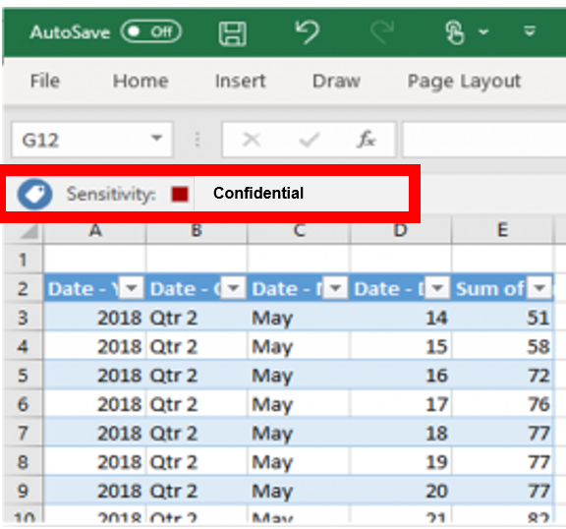

if you are an unauthorized user, you will be denied access to see the data
this verification ensures that only appropriate users have access to view the data, which helps you make sure that your data is secured

Manage Datasets in Power BI
Introduction
One dataset can be used to create multiple Power BI reports

Useful as preparing and cleaning data can be time-consuming, sharing datasets can be a productivity boost for report authors

sharing of datasets need to be actively managed for optimal organizational performance
hence you should:
automate the refresh process so that it becomes more efficient and users always have access to the latest data

promote certain datasets over others so that users can clearly identify the best dataset to use

Management also implies:
- implementation of PARAMETERS within datasets
  - helps with decision making and solving business problems
  - parameters can be used to change the server or database name of your dataset or a file path for a data source
  - can also be used to configure incremental refreshes of your data
  - also to run “what-if” scenarios and conduct scenario-type analysis of data

- setting up and maintaining a GATEWAY
  - so that users can access on-premises data source from the cloud
  - you will also have to prepare for potential issues that might arise regarding this gateway
    - could interrupt user access to the datasets
      - inability to access data leads to inability to do their job
      - organizational decision-making grinds to a halt

Create Dynamic Reports with Parameters
Dynamic reports are reports in which the data can be changed by a developer according to user specification

Dynamic reports are valuable because single reports can be used for multiple purposes

You can use parameters by determining the values that you want to see data for in the report
report updates accordingly by filtering the data for you

Dynamic reports give users more power over the data that is displayed in the reports, they can change the data source and filter the data by themselves

Create Dynamic Reports for Individual Values

To create a dynamic report, you first need to write an SQL query. Then you will use the Get data feature in Power BI desktop to connect to the database

An example of a dynamic report being queried using the Get Data for SQL server selection is seen below:

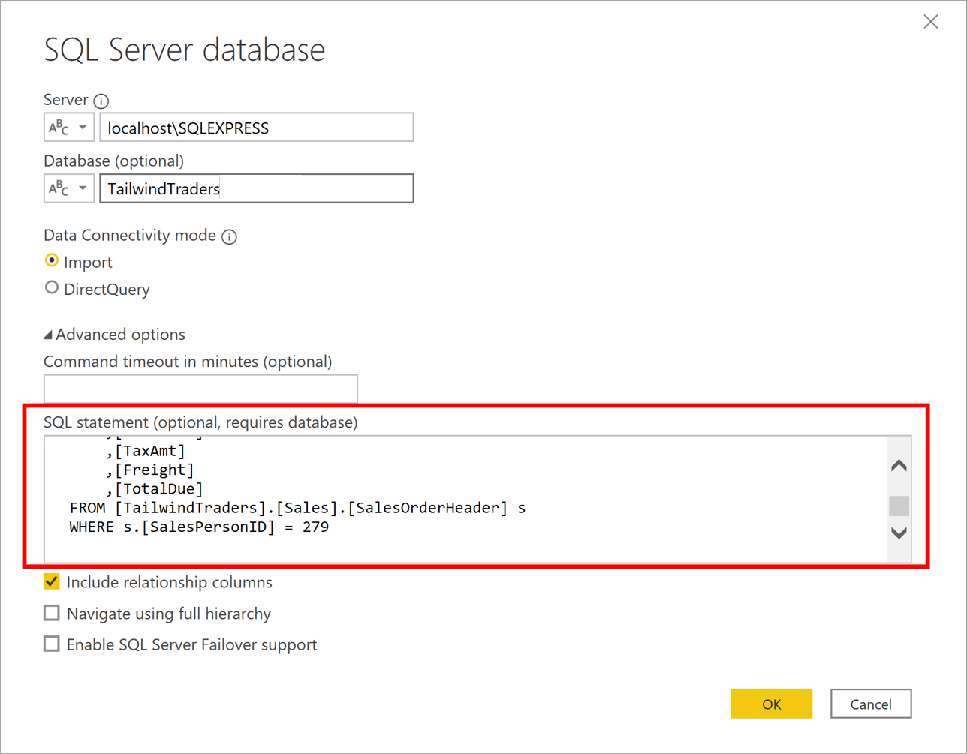
You then select Manage parameter => New parameter to create a new parameter as seen below
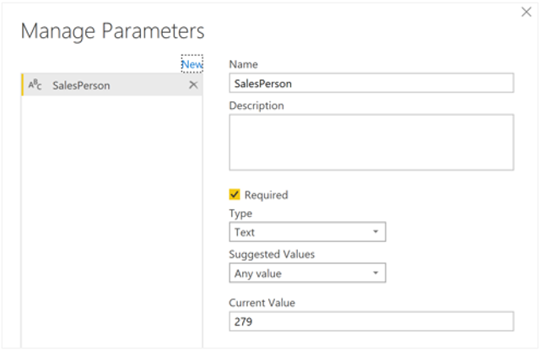

The result is a new query for the parameter being shown to have created, as seen below:
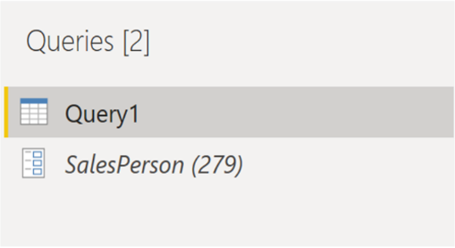

Click on the Advanced editor which allows you replace the existing value and enter a parameter name

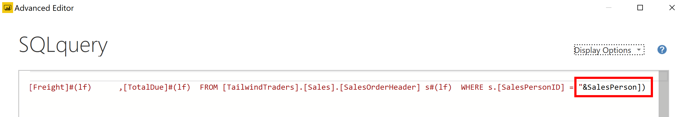

All of this then allows you to search by a stated query as the SQL query has been configured to pull information by a parameter

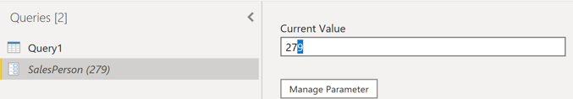
After executing the above value, the data for the value set to the parameter (in the example 279) is then pulled from the SQL database, the result of which can be seen below:
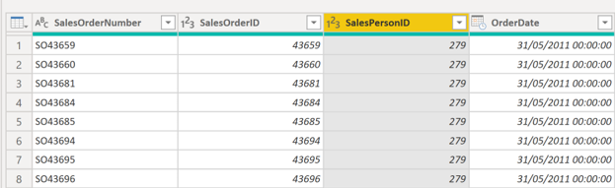

What-If Parameters
can be used to run scenarios and scenario-type analysis on the data.

Powerful additions to your Power BI data models because they enable you to look at historical data to analyse potential outcomes

Can be used to help you look forward, to predict or forecast what could happen in the future

e.g.,
determine the effect of increased sales to deeper discounts, or to let sales consultants see their compensation if they meet certain sales goals or percentages

Use a Power BI Gateway to Connect to On-Premise Data Sources
Gateway software acts like a bridge

It allows organizations to retain databases and other data sources on their on-premise networks and access that on-premises data in cloud services, such as Power BI and Microsoft Azure Analysis Services

A gateway facilitates quick, behind-the-scenes communication that flows from a user in the cloud to your on-premises data source and then back again to the cloud

A visual depiction of a gateway can be seen below:

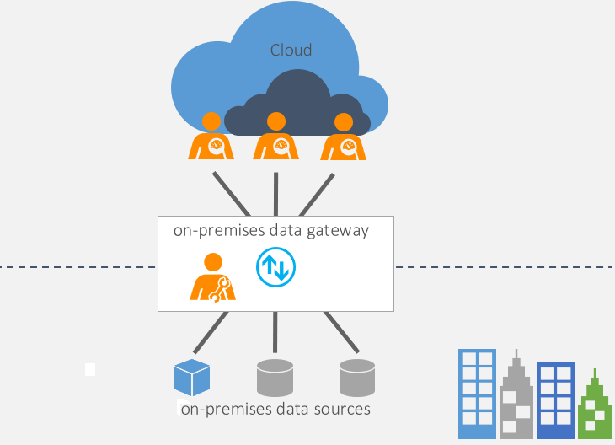

Two types of on-premises gateways are:
- Organization mode
  - Allows multiple users to connect to multiple on-premises data sources and is suitable for complex scenarios

- Personal mode
  - Allows one user to connect to data sources.
    - This type of gateway can be used only with Power BI
    - Can’t be shared with other users
  - Suitable in situations where you’re the only one in your organization that creates reports

Use an On-Premise Gateway
Connecting to an on-premise data source requires installation of an on-premises data gateway and then configure it to suit your organizational needs

The following occurs when connecting/connected to an on-premises data source

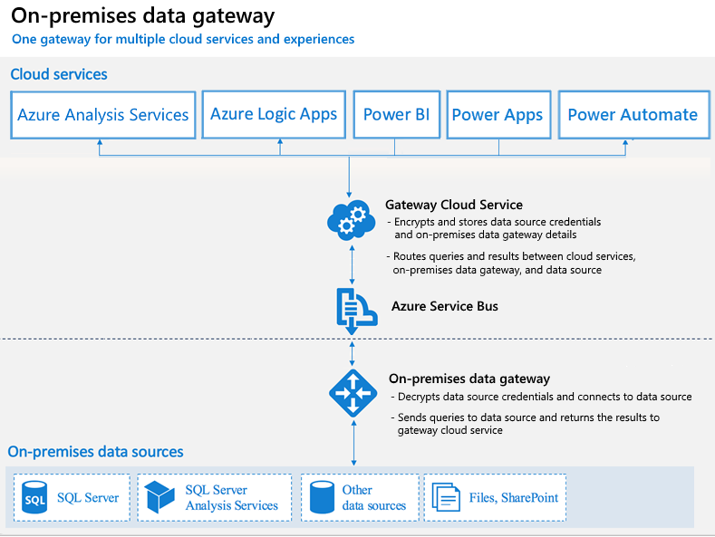
Configure a Dataset Scheduled Refresh
The scheduled refresh feature in Power BI allows you to:
define the frequency and time slots to refresh a particular dataset

Scheduling the refresh of your data will:
- save you time because you don’t have to manually refresh the data
- ensure that users can access the most up-to-date data
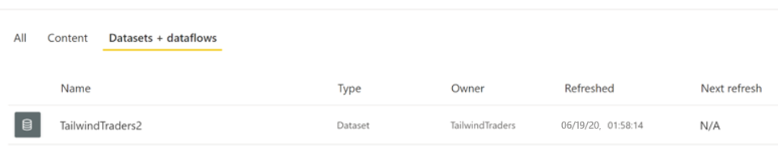
An example of a query whose last refresh date was 10 days ago, and does not have an upcoming data for a scheduled data refresh.
Set-up a Refresh Schedule
To set-up a refresh schedule, you need to have create a gateway connection

Go to the Datasets + Dataflows page, hover over the dataset and select the Schedule refresh icon
=> on the Settings page, turn on the Scheduled refresh feature
=> select the Refresh frequency, and ensure that the correct time zone is selected
=> add the time(s) that you want the refresh to occur
=> when you finished configuring the scheduled refresh, select Apply

You can configure up to:
- 8 daily time slots if your dataset is on shared capacity
- 48 time slots on Power BI Premium

The example below illustrates the sales data being refreshed on a DAILY basis at 6:00 AM, 10:00 AM and 3:00 PM
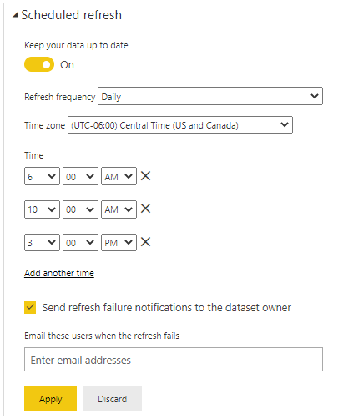

When you have configured a refresh schedule, the dataset settings page informs you of the next refresh times, as shown in the following image:
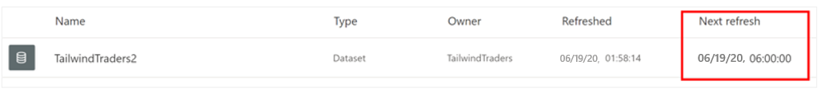
Perform an On-Demand Refresh
You can refresh a dataset at any time by performing an on-demand refresh.

This type of refresh doesn’t affect the next scheduled refresh time

This might be used when testing your gateway and data source configuration
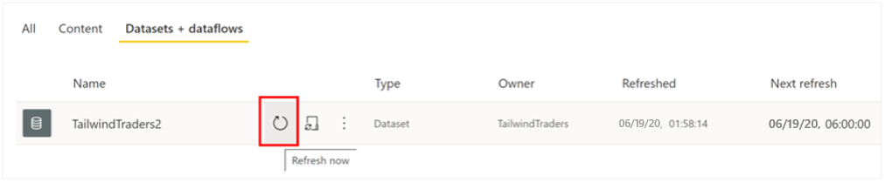

Check the Refresh Status and History
This feature is helpful when you want to find out:
- when the last refresh occurred and when the next one is scheduled
- It is also good practice to check the status of your dataset occasionally to check if refresh errors have occurred

Good to check refresh history occasionally to review the success or failure status of past synchronization cycles

An example can be seen below:
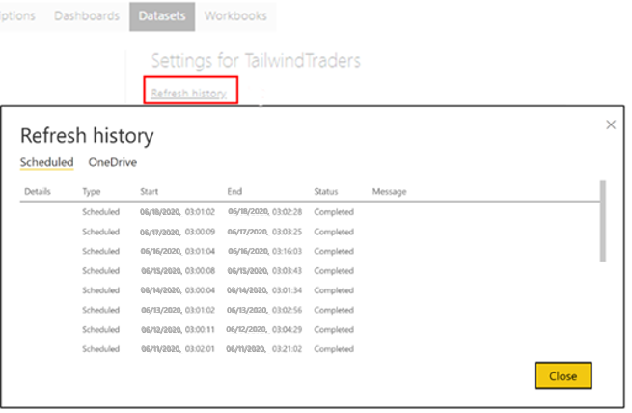

Configure Incremental Refresh Settings
The incremental refresh feature in Power BI is a popular feature because it allows you to refresh large datasets quickly and as often as you need, without having to reload historical data each time

Incremental refresh should only be used on data sources and queries that support query folding

Incremental refresh allows the following benefits:
- Quicker refreshes – Only data that needs to be changed gets refreshed
  - e.g., if you only need to refresh data from the last 10 days you can do so instead of refreshing the entire dataset
- More reliable refreshes
  - Do not need to keep your long-running data connections open to schedule a refresh
- Reduced resource consumption
  - Since you only need to refresh the smaller amount of data, the overall consumption of memory and other resources is reduced

Hence, you can define an incremental refresh policy to solve this business problem. This process involves the following steps:

- Define the filter parameters
Large datasets are commonly filtered when imported to Microsoft Power BI

For incremental refresh, the datasets are filtered by two date/time parameters:
RangeStart and RangeEnd

These two parameters are used as a filtering window because they restrict the used data to the range that is listed in the start and end dates

- Use the parameters to apply a filter
- Define the incremental refresh policy
- Public changes to Power BI service

Manage and Promote Datasets
Useful for when you have many different datasets that can be accessed by users

This allows you to direct users to the most up-to-date and highest-quality datasets in your workspace

Hence, it is important to create and share optimized datasets and endorse those datasets as the one source of truth

Report creators can then reuse those endorsed datasets to build accurate, standardized reports

Power BI provides two ways to endorse your datasets:
- Promotion
  - Promote your dataset when they’re ready for broad usage.
  - Power BI Admins have permissions to promote datasets

Promote a Dataset
You can only promote a dataset if you’re a Power BI Admin User or the Owner of that dataset

A badge in the endorsement column for that dataset will appear, indicating that its ready for viewing by all of your users.

- Certification
  - Request certification for a promoted dataset from an admin user that is defined in the Dataset Certification tenant admin setting
  - Certification adds another layer of security for the dataset
  - Certification can be a highly selective process
    - So that the only truly reliable and authoritative datasets are used across the organization

Certification requires permission from the dataset owner to access to the dataset

Certify a Dataset
Can be done by selecting the Certified option in the Endorsement settings selection

Technically,
A certified dataset is above a promoted dataset

Query Cache
Using the local caching services of Power BI to process query results

Instead of relying on the dataset to calculate queries, which when overloaded can reduce performance

you can use CLOUD RESOURCES on your PREMIUM capacities on the Power BI service to load your report, and thereby, ensure constant performance

Query Caching
a local caching feature that maintains results on a user and report basis.

This service is only available to users with Power BI Premium or Power BI Embedded

When using query caching, the query results are only specific to a user, and you can only use query caching on a specific page of a report

Several benefits of using query caching include:
- Improvement of the performance of reports, dashboards, and dashboard tiles by reducing loading time and increasing query speed
- Respects bookmarks and default filters, so enabling query caching keeps any presently created bookmarks
- Cached query results are specific to the user
- All security labels are followed

***** Row-Level Security
Power BI can help you secure reports and workspaces by allowing you to share them to active directory users and groups

You can also share a single report but have users see different data according to their job role

An example scenario
employees can only see sales from their department, Maria from Clothing should ONLY BE ABLE to see sales from the CLOTHING department

Row-level security uses a DAX filter as the core logic mechanism to ensure that only the appropriate person can view the appropriate records

DAX filters are (usually) applied on the dimension table, hence Row-level security performs better when the data is organized in a star schema

Two ways of implementing row-level security in Power BI:

Row-level security involves several configuration steps, which should be completed in the following order:
- Create a report in Microsoft Power BI Desktop
  - Import the data
  - Confirm the data model between both table
  - Create the report visuals

- Create RLS roles in Power BI Desktop by using DAX
Select the Modelling tab, then select Manage Roles
=> On the Manage roles page, select Create

Power BI row-level security (RLS) uses DAX to control who can see which data.

Consider it as always adding another filter to the appropriate users, regardless of the filters, slicers, or interactions that the user chooses on the Power BI report

- Test the roles in Power BI Desktop
You can validate that the filter is working by selecting the Modelling tab and then selecting View as Roles
=> e.g., select a role to view as (e.g., “Game”). The report now renders as if you were in that role, and you will only see the records that are included in the Game Department

- Deploy the report to Microsoft Power BI service

- Add members to the role in Power BI service
In the Row-Level Security screen accessible after clicking on the elipsis (…) icon and then the Security tab, you can add:
- Microsoft Azure Active Direction (Azure AD) users
- Security groups
to the created security roles

row-level security (RLS) will only apply to members who are ADDED TO THE ROLE ON POWER BI SERVICE.

Hence, if members were not added to the role, but have access to the report, RLS will NOT apply to them

An example of configuring Row-Level Security (RLS) on the Power BI Service page is seen below:
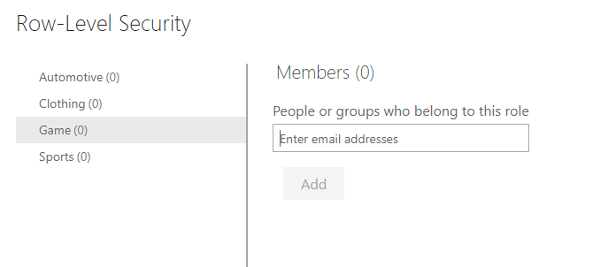
- Test the roles in Power BI service

- Static method
Uses a FIXED/STATIC value in the DAX filter

Once you’ve reached step 2, the view should be similar to this
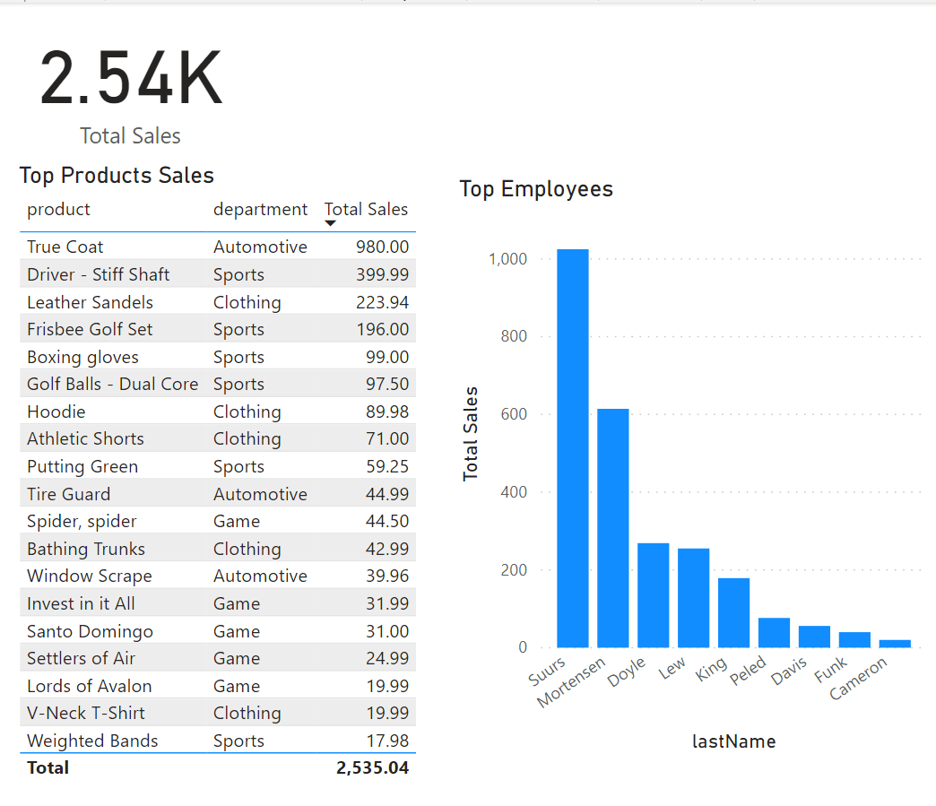

Hence, we will be limiting visibility of the columns so that only employees of a specific department can see their own sales

On the Manage Roles page:
- Create a role for each department, and then add a DAX expression to it
- For instance, you can create a role called Game
- And then add a DAX expression [department] = “Game”. Then whenever a member of that role interacts with the report, Power BI will add a filter to their interaction, thus limiting what they see

NOTE: a fixed value is used in the filter on the right side of the equal sign, e.g., (“Game”).
Hence, the intention is that
if you ever need to add a category, you will need to create a new role with a new value in the DAX expression

Notice that the DAX filter is applied on the dimension table.

An example is seen below,
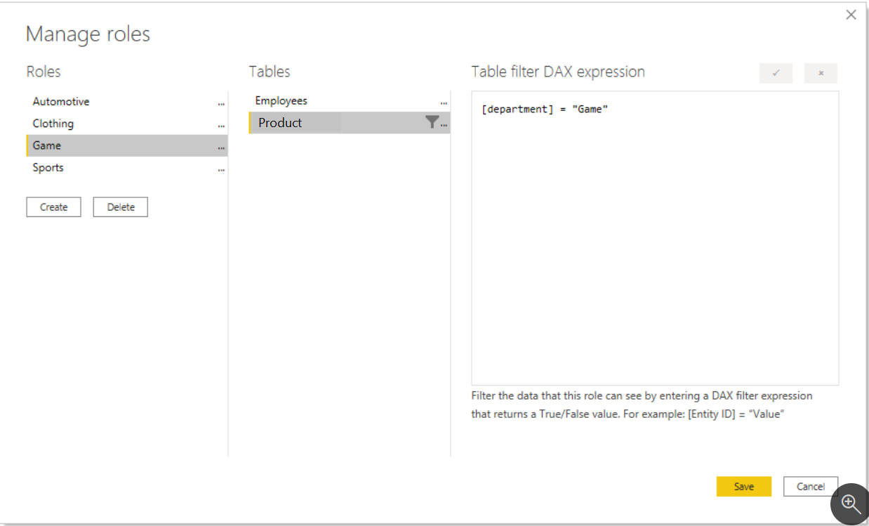
- Dynamic method
Uses a DAX function

You can set up row-level security (RLS) only once, WITHOUT the need to continue maintaining it dynamically

an example scenario:
Configuring row-level security (RLS) to only show sales to the person who made them.
e.g., Russell King has made four sales. When viewing the report, Russell should only see the sales that he is responsible for and no other sales

Row-level security (RLS) can then be configured in the same manner as before, with one change

Instead of creating four roles, we only need to create one role. The DAX filter for that one role would look similar to the following image:
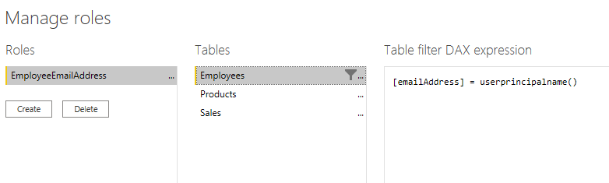
Notice that instead of the fixed string, such as Game or Clothing, this uses a DAX function in the row-level security filter

The userprinciplename() function will
compare the email address from the Employees table with the email address that the user entered when signing into the Power BI service

If he used a company email address similar to the one stored in the Employees table to sign-in to Power BI service, the system will compare that value to the email address in the Employees table

However, this ASSUMES that a relationship has been created between Employees and Sales
if it has then Russell will only see his four sales

Hence the USERPRINCIPALNAME() DAX function will:
tell you the username of the person who is signed in to Power BI service

